**Test 03 CPP**

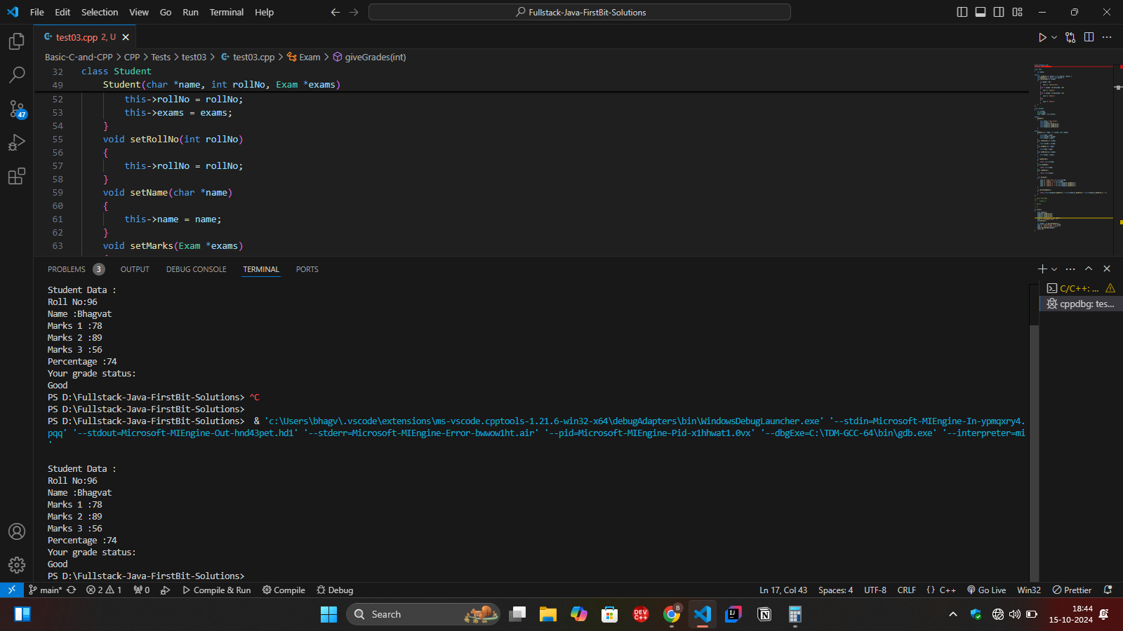

using namespace std;

#include <bits/stdc++.h>

class Exam

{

    int marks;

public:

    void setMarks(int marks) { this->marks = marks; }

    int getMarks() { return this->marks; }

    void giveGrades(int grade)

    {

        if (grade > 80)

        {

            cout << "\nExcellent";

        }

        else if (grade > 65 && grade < 80)

        {

            cout << "\nGood";

        }

        else if (grade > 50 && grade < 65)

        {

            cout << "\nPass";

        }

        else

        {

            cout << "\nFail";

        }

    }

};

class Student

{

    int rollNo;

    string name;

    Exam *exams = new Exam[3];

public:

    Student()

    {

        this->name = "Not Given";

        this->rollNo = 0;

        this->exams[0].setMarks(0);

        this->exams[1].setMarks(0);

        this->exams[2].setMarks(0);

    }

public:

    Student(char *name, int rollNo, Exam *exams)

    {

        this->name = name;

        this->rollNo = rollNo;

        this->exams = exams;

    }

    void setRollNo(int rollNo)

    {

        this->rollNo = rollNo;

    }

    void setName(char *name)

    {

        this->name = name;

    }

    void setMarks(Exam *exams)

    {

        this->exams = exams;

    }

    int getRollNo()

    {

        return this->rollNo;

    }

    string getName()

    {

        return this->name;

    }

    Exam *getMarks()

    {

        return this->exams;

    }

    void display()

    {

        cout << "\nRoll No:" << this->rollNo;

        cout << "\nName :" << this->name;

        cout << "\nMarks 1 :" << this->exams[0].getMarks();

        cout << "\nMarks 2 :" << this->exams[1].getMarks();

        cout << "\nMarks 3 :" << this->exams[2].getMarks();

    }

    int percentageCalc()

    {

        return (this->exams[0].getMarks() + this->exams[1].getMarks() + this->exams[2].getMarks()) / 3;

    }

};

// class ResultMgt

// {

//     Student s;

// public:

// };

int main()

{

    Exam exams[3];

    exams[0].setMarks(78);

    exams[1].setMarks(89);

    exams[2].setMarks(56);

    Student s1("Bhagvat", 96, exams);

    cout << "\nStudent Data : ";

    s1.display();

    int grade = s1.percentageCalc();

    cout << "\nPercentage :" << grade;

    cout << "\nYour grade status: ";

    exams->giveGrades(grade);

    return 0;

}